**SHORT ANSWER**

1. You are a venture capitalist. Calculate the Profit Margin for 2014 for the company whose income statement is shown below (show work).

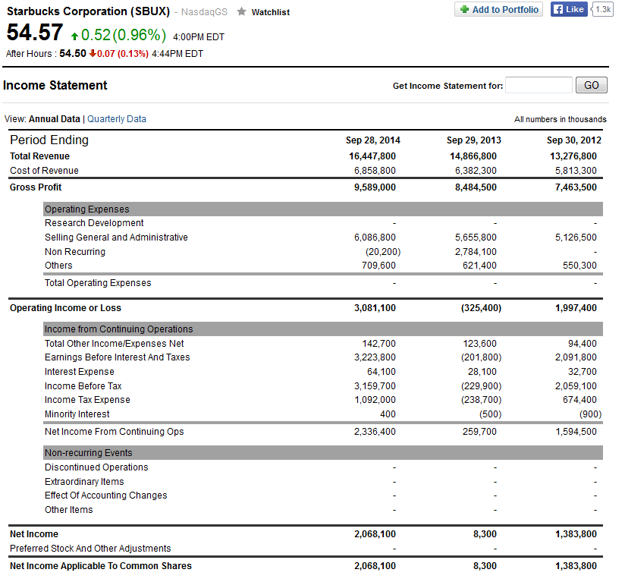

1. You are planning to start a startup and use Porter’s 5 Forces to analyze the industry. You do not find any rivals and so report that the threat from rivalry among existing competitors does not exist and thus is low. Briefly discuss both why this may be a good thing and also why it may be a negative thing.

**LONG ANSWER**

You are going to start a business of your choice. Choose **one** of the following.

1. A fashion and clothing store
2. A coffee shop or restaurant
3. A firm designing smart phones running the android operating system
4. A micro-brewery

Use what you have learned in class to assess the following questions. If you do not answer a question you will **not** receive credit for it so make sure to double check that you have in fact answered everything.

Part A: Discuss how you would assess the attractiveness of entering this industry.

Part B: Discuss how you would raise funding to support your business and justify why you chose this type of funding.

Part C: Discuss how you would use technology to improve your chances of success and also connect with your customers more efficiently.